**Team id: PNT2022TMID34154**

Project Milestone & Activity Planning:

Milestone:

Modern Technology is increasing and optimizing the Performance of the Artificial Intelligences (AI) Model.

Based Crop Yield Disease Prediction System, is helpful for farmers to prevent the crop from various diseases can identify the Disease within the process of capturing the Image at the plant and the Machine Learning Algorithm will give the affected Disease Name.

In this Project Milestone will be given the Best Solution for the farmer using a completely friendly and simple user interface web application to fetch the solution on its own.

In addition, a process we are planning to add a valid Module that is a Fertilizer recommendation for the Specific Disease. It can give both Artificial fertilizer and Natural fertilizers in a suggestive manner.



Activity List:

In Project, Management Planning is an important task for scheduling the phase of the project for the Team Members.

This Activity can show the various activity are allocated and Done by the Team Members!

In Project we can Split into the Four Step of Phrases are

Phrase 1: Information Collection and Requirement Analysis

Phrase 2: Project Planning and Developing Modules

Phrase 3: Implementing the High-Accuracy Deep Learning Algorithm to Perform

Phrase 4: Deploying the Model on Cloud and Testing the Model and UI Performance

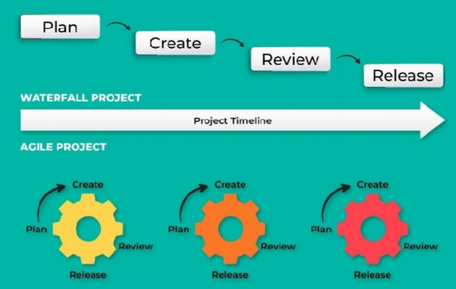

Agile Methodology for Activity Planning